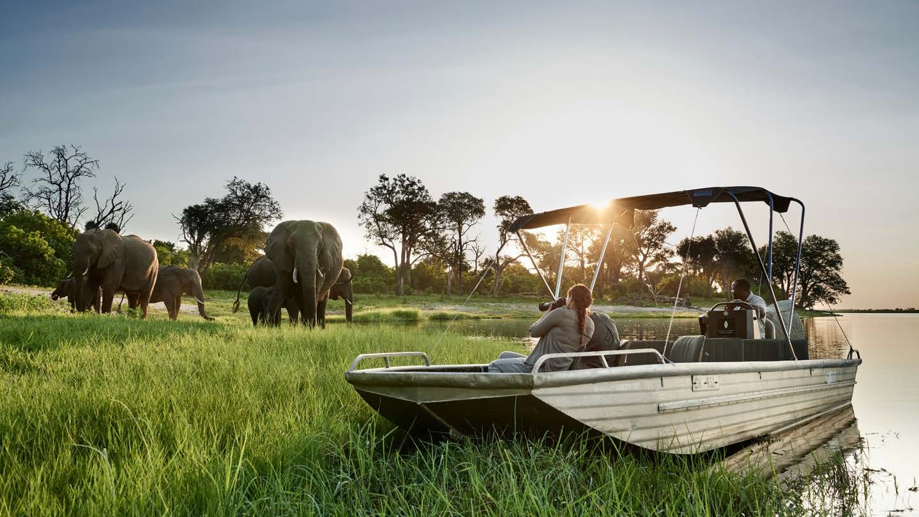

2025 Annual Offers & Special Offers

*East and Southern Africa*

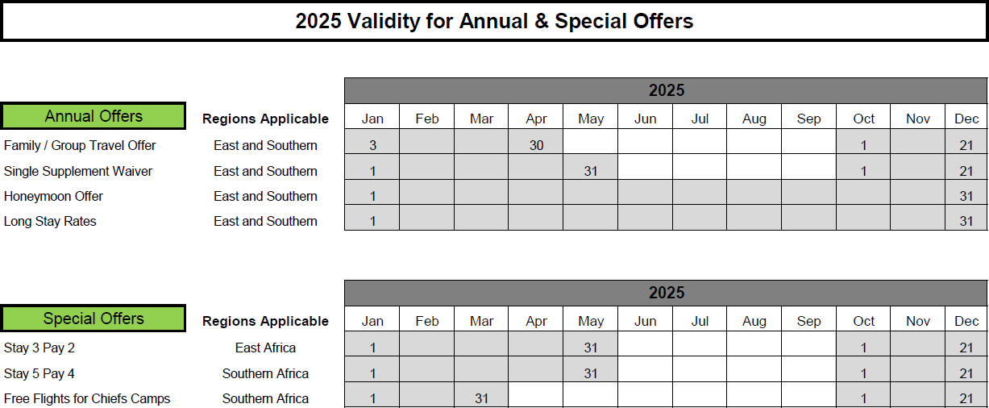

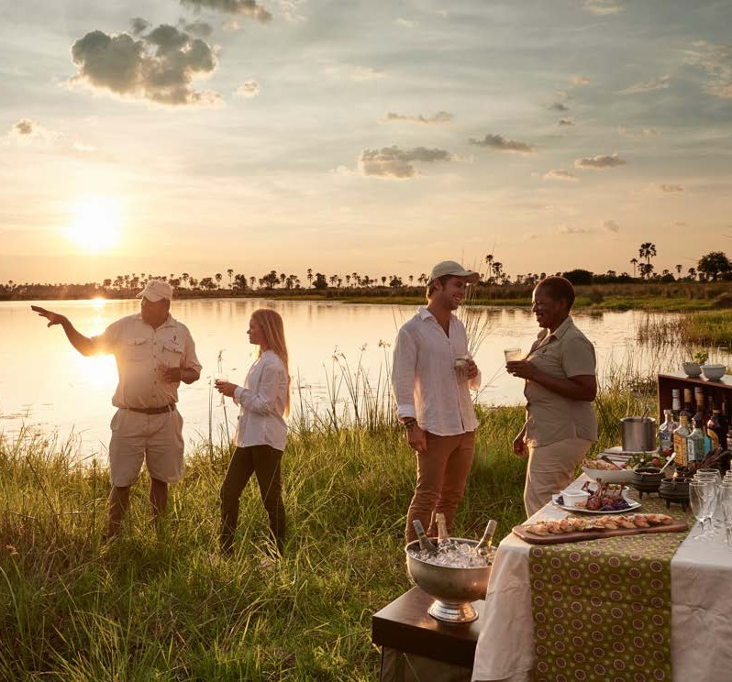

**Annual Offer**

**East and Southern**

# FAMILY / GROUP TRAVEL OFFER

## Experience a family group safari like no other at our camps and lodges across Africa

**FOR GROUPS OF EIGHT FULL PAYING GUESTS, ONE GUEST TRAVELS FREE**

**FOR GROUPS OF 12 FULL PAYING GUESTS, TWO GUESTS TRAVEL FREE WITH**

**TWO PRIVATE VEHICLES**

###### TERMS & CONDITIONS:

* Valid for travel from 3 January 2025 – 30 April 2025; 1 October 2025 – 21 December 2025
* Valid for travel to all Sanctuary camps and lodges across East and Southern Africa
* Offer applies for groups with 6+ full paying adults. Children aged 6+ count towards the minimum pax
* Cannot be combined with any other offers
* Excludes Geoffrey Kent Suite at *Sanctuary Olonan*a, Private Villa at *Sanctuary Tambarare* and Geoffrey Kent Suite at *Sanctuary Chief’s Camp*
* Subject to availability
* Offer can be withdrawn at any time

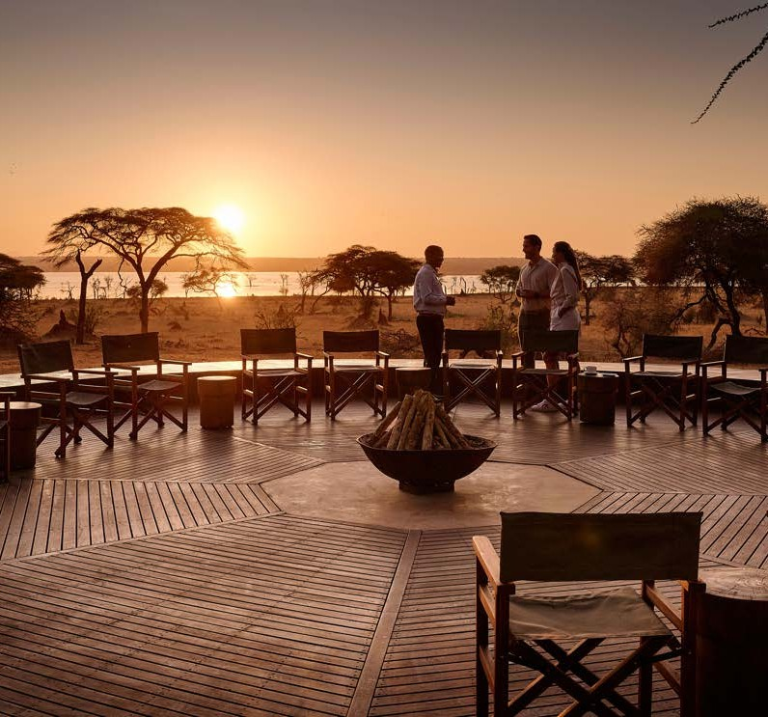

**Annual Offer**

**East and Southern**

# SINGLE SUPPLEMENT OFFER

## Our single supplement will be waived in specific seasons for all our camps and lodges across East and Southern Africa

##### TERMS & CONDITIONS:

* Valid for travel from 1 January 2025 – 31 May 2025; 1 October 2025 – 21 December

2025

* Offer can be combined with long stay discount for even greater savings. Cannot be combined with any other offers
* Excludes Geoffrey Kent Suite at *Sanctuary Olonana*, Private Villa at *Sanctuary Tambarare*

and Geoffrey Kent Suite at *Sanctuary Chief’s Camp*

* Subject to availability
* Offer can be withdrawn at any time



**Annual Offer**

**East and Southern**

# HONEYMOON OFFER

## Experience a honeymoon like no other with Sanctuary Retreats

### SPEND YOUR HONEYMOON AT OUR PORTFOLIO OF

**LUXURY SAFARI CAMPS AND LODGES AND RECEIVE 50% OFF YOUR STAY FOR YOU OR YOUR PARTNER**

##### TERMS & CONDITIONS:

* Valid for travel between 1 January 2025 and 31 December 2025
* Minimum stay 2 nights
* Offer can be combined with long stay discount for even greater savings. Cannot be combined with other offers
* Valid for travel within 6 months of marriage certificate
* Excludes Geoffrey Kent Suite at *Sanctuary Olonana*, Private Villa at *Sanctuary Tambarare*

and Geoffrey Kent Suite at *Sanctuary Chief’s Camp*

* Offer can be withdrawn at any time

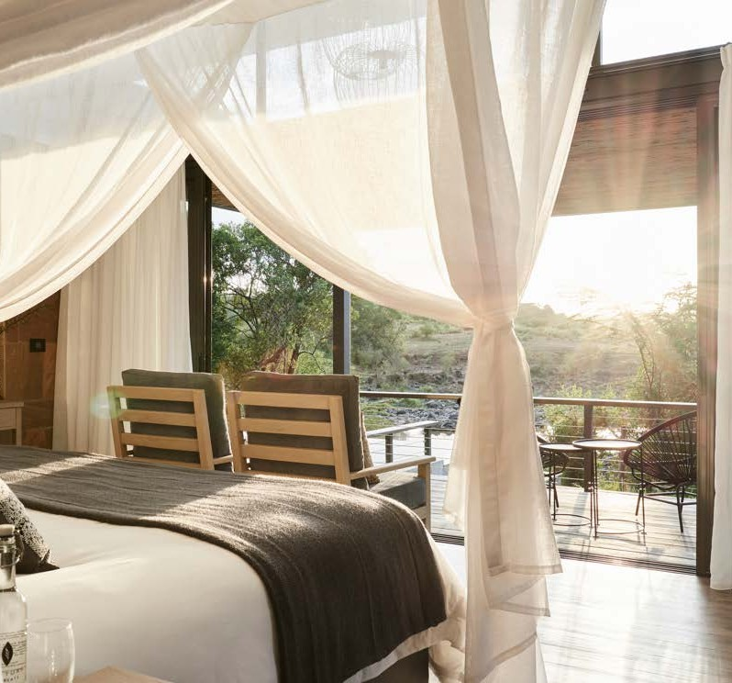

**Annual Offer**

**East and Southern**

# STAY LONGER PAY LESS

## Enjoy extra on your safari getaway with Sanctuary Retreats’ extended stay offer, valid for 2025, when you stay at one or more of our properties

### STAY 4-6 NIGHTS AND SAVE UP TO 25% STAY 7+ NIGHTS AND SAVE UP TO 30%

##### TERMS & CONDITIONS:

* Valid for travel between 1 January 2025 and 31 December 2025
* Offer can be applied to single and multi-camp stays at any of our camps and lodges
* Percentage discount varies based on selected property, seasonality and length of stay
* To find out more about this offer, please refer to the rates sheets of each property

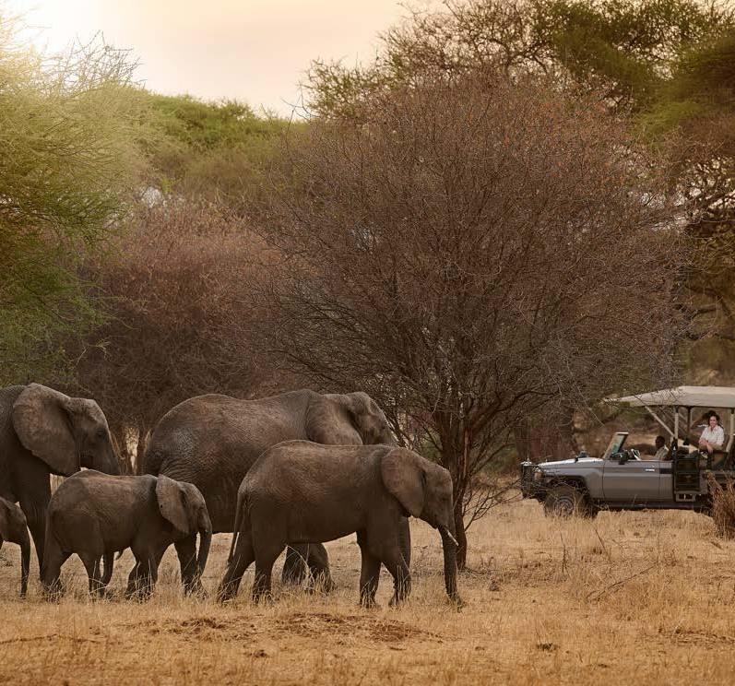

**Special Offer**

**East Africa**

# STAY 3 NIGHTS, PAY 2 IN EAST AFRICA

## Stay 3 nights at our safari camps and lodges in Kenya and Uganda and receive your 3rd

*night free*

### KENYA, UGANDA AND TANZANIA

*Sanctuary Olonana, Sanctuary Tambarare*, *Sanctuary Gorilla Forest Camp, Sanctuary Swala, Sanctuary Kichakani, Sanctuary Ngorongoro Crater*

1 January - 31 May 2025 and 1st October - 21st December 2025

###### TERMS & CONDITIONS:

* Valid for travel from 1 January - 31 May 2025 and 1st October - 21st December 2025
* Can be combined with our long stay discount
* Cannot be combined with any other offers
* Excludes Geoffrey Kent Suite at *Sanctuary Olonana* and Private Villa at *Sanctuary*

*Tambarare*

Subject to availability

 Offer can be withdrawn at any time  3rd night is free



**Special Offer**

**Southern Africa**

# STAY 5 NIGHTS, PAY 4 IN SOUTHERN AFRICA

## Stay for five nights at our safari camps and lodges in Southern Africa and receive your fifth night free

###### TERMS & CONDITIONS:

* Valid for travel from 1 January - 31 May 2025 and 1st October - 21st December 2025
* Valid for all camps and lodges in Botswana: *Sanctuary Baines’ Camp, Sanctuary Chief’s Camp, Sanctuary Chobe Chilwero and Sanctuary Stanley’s Camp; Namibia: Okahirongo Elephant Lodge and Zambia: Sanctuary Sussi & Chuma*
* Offer can be combined with long stay discount for even greater savings. Cannot be combined

with any other offers

* Excludes Geoffrey Kent Suite at *Sanctuary Chief’s Camp*
* Subject to availability
* Offer can be withdrawn at any time
* Fifth night is free if itinerary is more than five nights

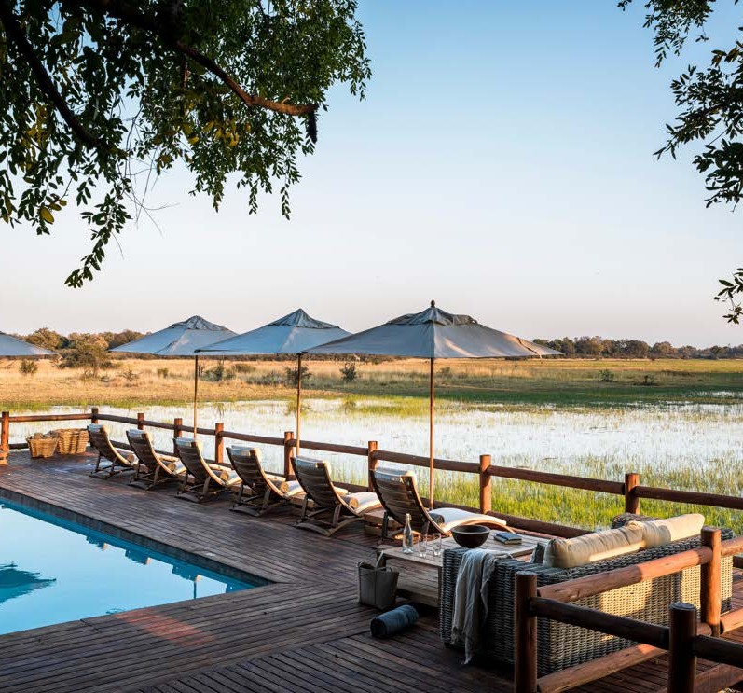

**Special Offer**

**Southern Africa**

# FREE FLIGHTS FOR

**SANCTUARY CHIEF’S CAMP**

## Stay for three nights at Sanctuary Chief’s Camp and receive free Mack Air scheduled flights to and from the camp

###### TERMS & CONDITIONS:

* Valid for travel from 1 January 2025 – 31 March 2025 and 1st October - 21st December 2025
* Valid for *Sanctuary Chief’s Camp* only
* Return flights from any other Okavango Delta lodge, Kasane airport or Maun airport to Chief's camp
* Only applicable for stays of 3+ nights
* Minimum 2 guests; maximum 6 guests per booking
* Offer can be combined with the long stay discount but not with other offers
* Subject to availability
* Offer can be withdrawn at any time

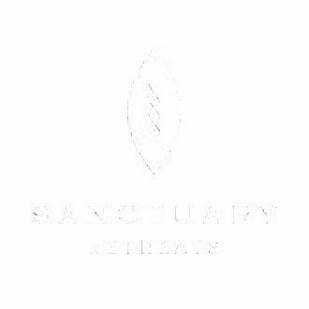

**CONTACT DETAILS**

For more information, please contact your preferred travel partner or our Sanctuary Retreats reservation centre in your destination of choice:

#### BOTSWANA, NAMIBIA AND ZAMBIA+

(27)11 438 4650

[reservations.safrica@sanctuaryretreats.com](mailto:reservations.safrica@sanctuaryretreats.com)

#### KENYA

+ (254) 20 248 7374

[reservations.kenya@sanctuaryretreats.com](mailto:reservations.kenya@sanctuaryretreats.com)

#### TANZANIA

+(255) 27 250 9817

[reservations.tanzania@sanctuaryretreats.com](mailto:reservations.tanzania@sanctuaryretreats.com)

#### UGANDA

+ (256) 776 340 290

[reservations.uganda@sanctuaryretreats.com](mailto:reservations.uganda@sanctuaryretreats.com)

#### EGYPT

+2 (02) 23947820

[reservations.egypt@sanctuaryretreats.com](mailto:reservations.egypt@sanctuaryretreats.com)

SANCTUARYRETREATS.COM